

International School

**Capstone Project 2**

CMU-SE 451

**Reflection**

**Date:** 13/05/2023

**Craft Village Pollution Monitor System**

**Submitted by**

**Ca, Van Cong Le**

**Huy, Bui Duc**

**Phuc, Hua Hoang**

**Trung, Nguyen Thanh**

**Nhan, Huynh Ba**

**Approved by**

**Ph.D. Nguyen Thanh Binh**

**Proposal Review Panel Representative:**

Name Signature Date

**Capstone Project 2 - Mentor:**

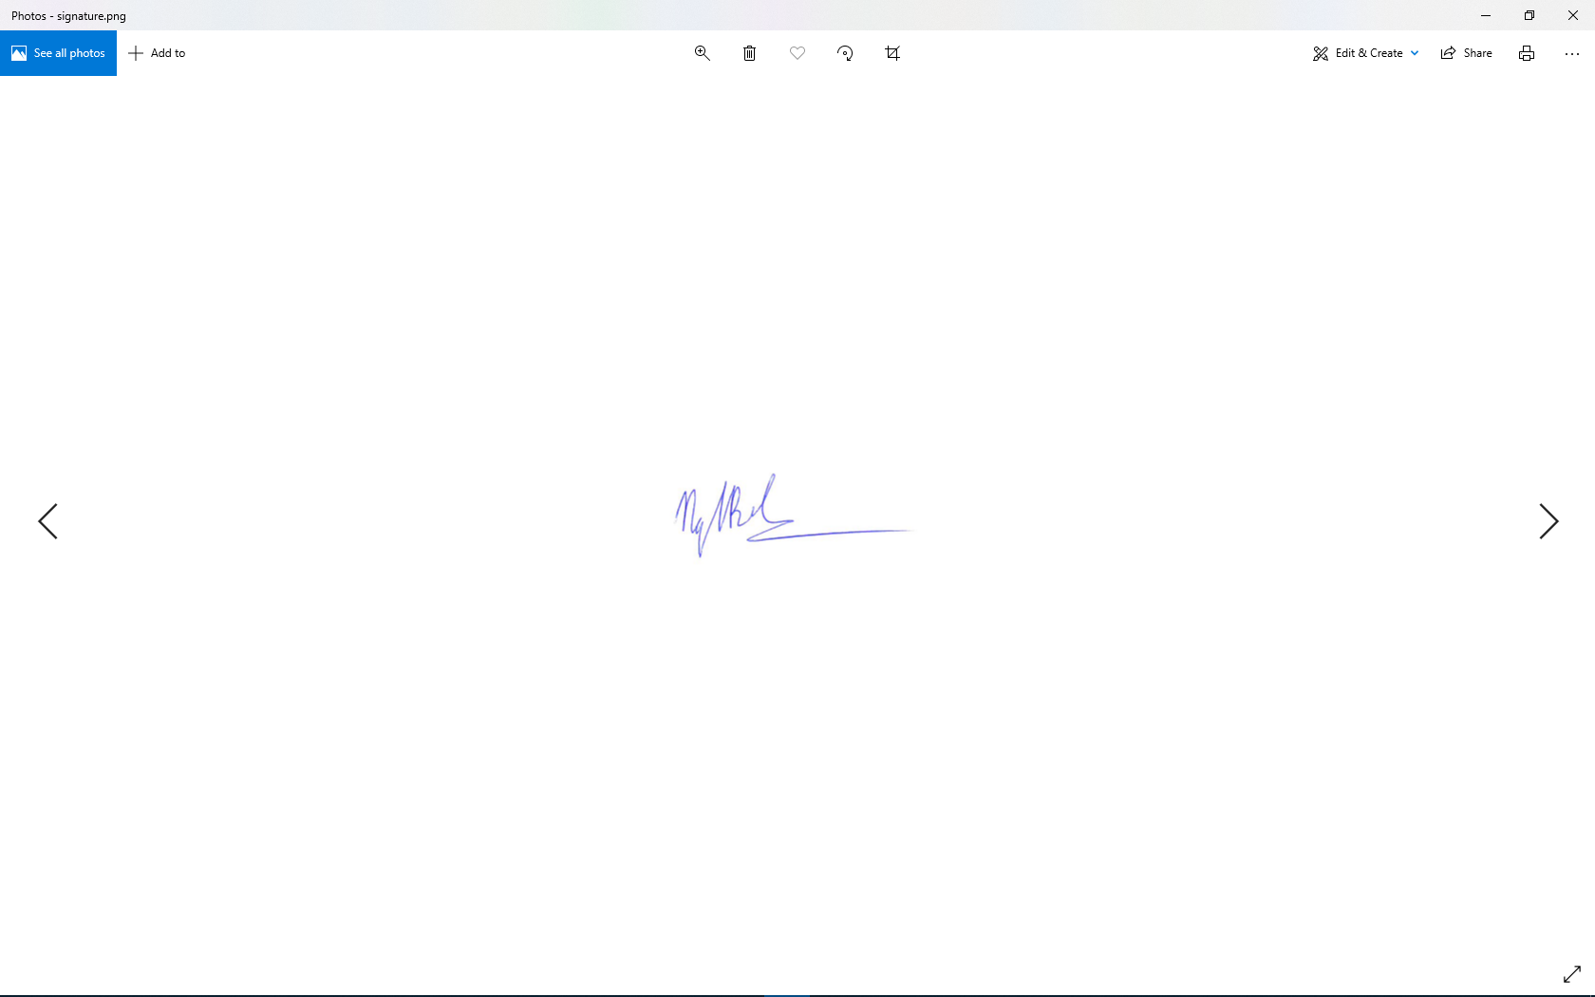

Name Signature Date

|  |  |
| --- | --- |
| **Team Number/**  **Team Name** | C2SE.01 |
| **Project title** | CVPMS – Craft Village Pollution Monitor System |
| **How many students are on your team? List the team member’s name** | 5  Ca, Van Cong Le  Huy, Bui Duc  Phuc, Hua Hoang  Trung, Nguyen Thanh  Nhan, Huynh Ba |

**Reflection (Required)**

**What challenges did you face while completing this project?**

* A common difficulty of the group in completing the project is new knowledge and technology. Our group has to get in touch with new knowledge and technology such as machine learning, location base, image processing, ...etc.
* Lack of communication is also a barrier for my team.
* Lack of practical experience. Estimating workload depends heavily on the feelings and experiences of each individual.
* Appropriately matching skills to project tasks requires the experience to know what skills are required for what tasks.

**What were the highlights for you/your team during this project?**

* New technology:
* Image Classification is used to predict pollution types from the input image.
* Location-based service is used to get user’s location automatically.
* The main point is that we apply these technologies to monitor pollution from craft villages. Currently, most of Vietnam's craft villages were and are now being polluted. Therefore, we hope that our system can encourage people of all ages to take part in protecting the environment.
* After working together for four months, individuals had positive changes in their opinions, ways of thinking and acting, and attitudes toward other people. We also felt more responsible for the work.
* We have successfully used machine learning technology to build a model that can predict the types of pollution from the input image.

**What is the most important thing you learned in this project?**

* Teamwork and communication, this always is an important thing when working with others. Although we already have time to work together but when starting doing something new, this job requires different skills and the ability to manage team members.
* We learned that it is very simple to develop features and modules when we understand the requirements.
* We gained experience in how to research previously unknown topics.
* Process and framework, estimating is also important. After going through this project, we have a better understanding and more accurate estimation of the time to complete the task, function scores, …
* Problem solving and accountability, in order to keep up with project progress, each team member always has the responsibility for the assigned work and instead of dealing with a big problem, we know how to divide small problems to handle them effectively.

**What part of the project did you do your best work on?**

Each team member will have strengths and they will do well in the following parts:

* Ca: Interface design, beautify the User Interface for the mobile application, participate in location-based service and AI technology research, collect data and integrate AI.
* Huy: Research on applying machine learning to classify environmental pollution from images, crawl and prepare data for training, train machine learning model, create API to predict and return the pollution types from the input image.
* Phuc: Interact with databases, develop Backend API services, research and deploy location-based service technology, collect data and integrate AI.
* Trung: Interface design, beautify the User Interface for the web application, participate in pollution AI technology research, collect data and integrate AI.
* Nhan: Interface design, beautify the User Interface for the web application, deploy the web application to the server, manage the project’s server, participate in pollution AI technology research, collect data and integrate AI.

**What was the most enjoyable part of this project?**

* Planning Poker activities. This is an activity that happens every Sprint starts. After the Product owner read each backlog, the team members asked to analyze and clarify this backlog. This is when the members give their opinions, evaluate the complexity of the backlog, give the score of the backlogs (corresponding to the execution time) and agree on their views.
* All members respect the opinions of others.
* Offline working with members: This is the time when everyone in the team exchange knowledge, talk best, consolidate the solidarity in the team.
* Sprint Retrospective. This is the activity that takes place at the end of a Sprint. Team members reviewed what was good and bad and what needed to be improved during the sprint. From there, the members are clear about each other and comfortably communicate and implement projects.

**What is the least interesting part of this project?**

* Making a professional and detailed document takes time and researches many aspects.
* It is possible for requirements to change at any time.
* Detailed planning for each task requires experience in project work and accurate time measurement for that task.

**What needs to be improved to make the project team work best?**

* The schedule should be more accurate and relevant.
* Improving risk management
* Participate more actively in working together, especially face-to-face meetings and daily meetings.
* There is a clear purpose.
* Set and follow the rules in the group.
* Accept differences.

**How could you/your mentor(s) change this project to make it better next time?**

* We should keep in touch with our mentors and report the difficulties that we are facing.
* More focus and discussion on the project.
* Release the application on many different other stores.
* Try to understand the problems faced by market applications and from that improve, apply and our application.